صورة تحتوي على نص, علامة, جهاز, إغلاق

تم إنشاء الوصف تلقائياً

**FACULTY OF ARCHITECTURE AND ENGINEERING**

**DEPARTMENT OF COMPUTER ENGINEERING**

**SPRING 2021/2 SEMESTER**

**Instructor: Ms. Layla Albabtin**

Alanoud Alqahtani: 201812115

Khulood Aldhahri: 201722210

Fatima Alfaraidy: 201912115

**Introduction**

Lately going to the gym is one of the important things in life, and what we are looking for is how to make this daily activity easy and fast , our program focused on booking class in the gym, the website shows the client’s exercise classes registration page during subscription.

Functional Requirements

1. The user shall be able to search for classes by trainer id, and name.
2. The system shall be able to check for available classes
3. The user shall be able to book class
4. The system shall add booking to the database and the class number of enrolled trainees should be increased.
5. The system shall display the information of class that selected by the user.

**Non-Functional Requirements**

1. The system shall be friendly and easy to use.
2. The system shall preserve backups of all database updates for each record.

**Used Tools& Technology**

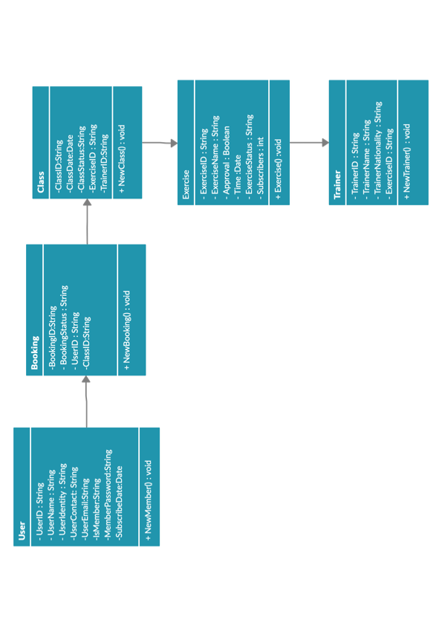**Er diagram:**

**Website Structured:**

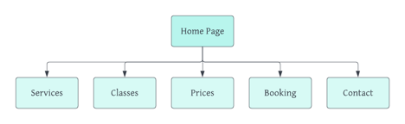

**Color Scheme:**

**User Interface Prototype:**

**Conclusion:**

In this project, we learned many things, including (connecting the database with php , system allow the user to login and register. , and how to work as a team in github), which will make us more creative, as we have achieved a high level in web programming.